|  |  |
| --- | --- |
| Name | Yash Shinde |
| NUID | 001493321 |
| Course | DWBI Online |

1. There are plenty of NULL Values in the health data set in every column:  
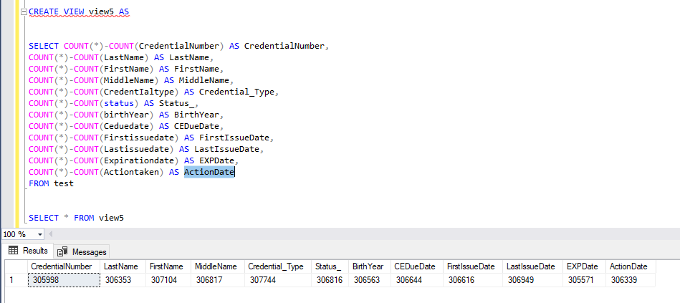

If these NULL Values were omitted the data set would have been more structured and smaller in size.

2. Some entries have birth year 1800 and FirstIssueDate more than 19470000 which makes no sense.



\

3. Between year 1860 to 1900 number of records reached lowest possible value

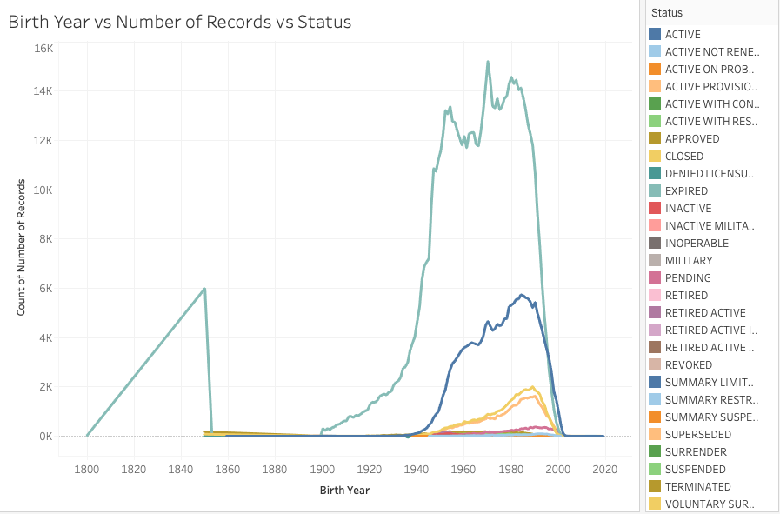

And raised exponentially after year 1900.

3. Dates in the database are recorded in YYYYMMDD format, if it was in default SQL format it would have been better to analyze data.